**CORRECTIONS (in bold red)**

**www.eurekapublications.net/corrections**

**Pages 2/3 – Chapter 1 – Worked Examples 1 & 2**

Reaction support **A should be a pin** andsupport **B should be a roller.**

**Page 106 – Chapter 5 – Worked Example 3**

The worked example should read as follows:

**Worked Example 3:**

In a Charpy Impact Test, a hammer of mass 9kg is released from a vertical height of **750 mm**. If the energy lost in fracturing the steel specimen is 65 J, to what vertical height will the pendulum rise to?

**Page 135 – Chapter 1 – Q.34a) Solution**

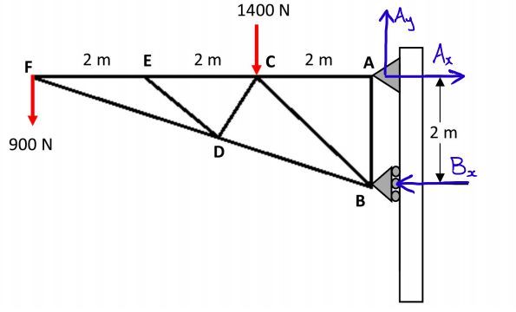

1. Apply sum of moments about A to find the reaction force at support B.

### **b)** Apply sum of forces in vertical and horizontal directions to find the reaction forces on A.

Draw up the vector triangle to find the resultant force acting on the pin support A by applying Pythagoras and trigonometry to find its direction.

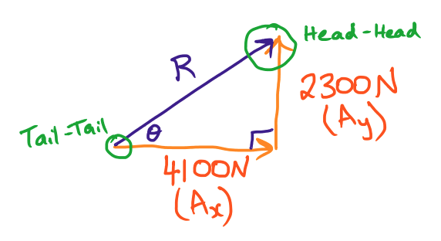

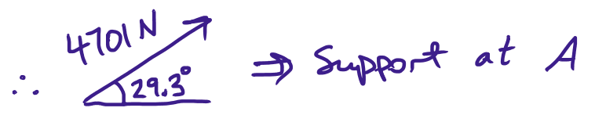

**Page 143 – Chapter 1 – Q.43a) Solution**



**Note**: Although the pin joint is at an angle, its components will always be directly vertical and horizontal. Also, when converting 2 tonnes to kilograms, we multiply by 1000 so we have 2000kg. Multiply this value by 10 to get force so 20000N. Divide by 1000 to convert to kN gives us 20kN.

Sum moments about I to find force at roller joint D.

Apply sum of forces in the vertical and horizontal directions to find the pin joint component forces.

Draw a vector triangle to find the resultant force at the pin joint along with its direction. Ensure that the resultant vector has a tail-tail and head-head connection with the other 2 vectors.

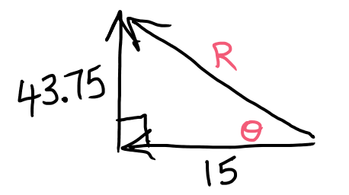

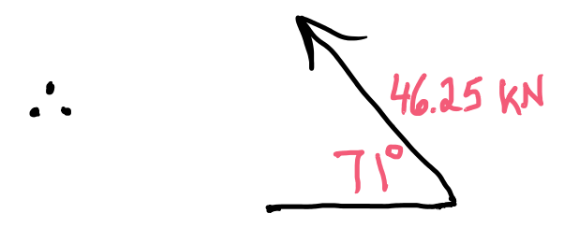

**Page 151-152 – Chapter 2 – Q.39 Solution:**

**Page 162 – Chapter 3 – Q.21c) Solution:**

Working out is correct. Answer should be **7304.2 N**

**Page 162 – Chapter 5 – Q.11 Solution:**



First find the distance that this box covers if it gains a height of 2m.

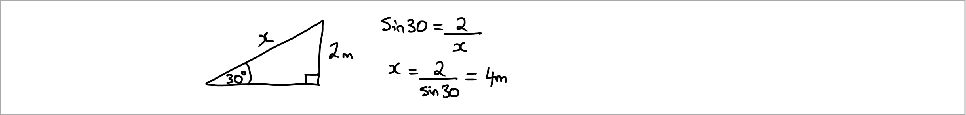

Find the force that is required to just get this box moving.

We now find the work done: